Session 6:

Topic : Sub-Queries - Scaler & Multi-Valued / Multi-Row

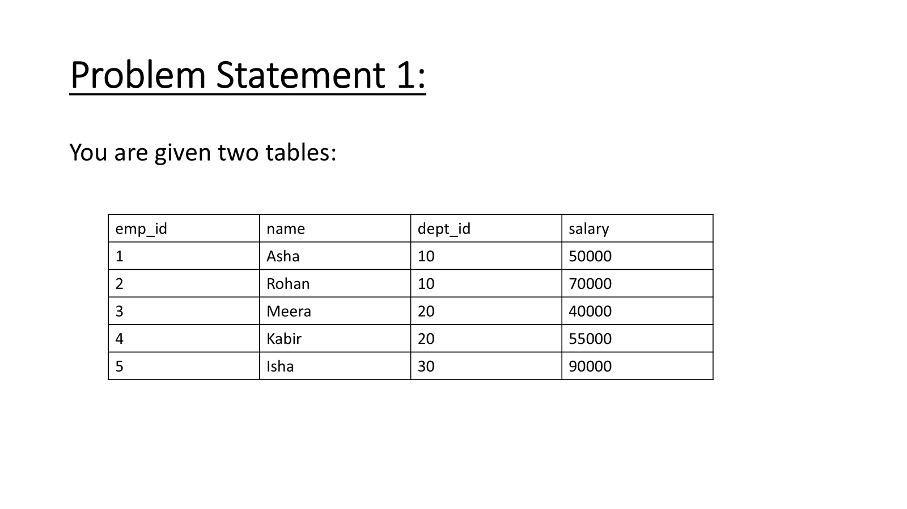

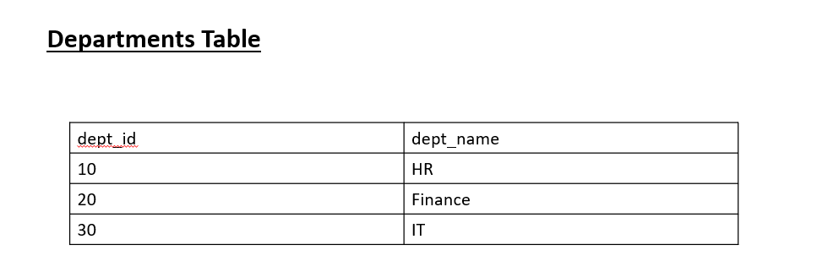

For each department, find the employee whose salary is closest to the department’s average salary.
(If two employees are equally close, return the one with the HIGHER salary)

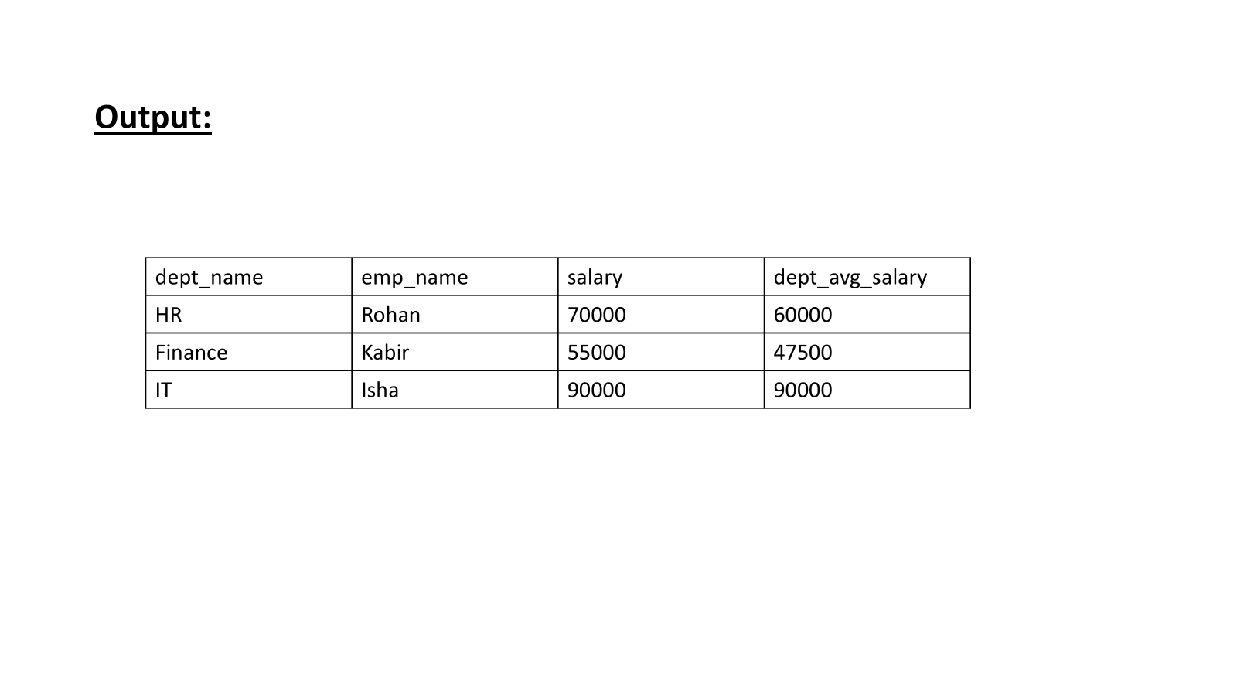
Solution

CREATE TABLE Employees (
emp_id INT PRIMARY KEY,
name VARCHAR(50),
dept_id INT,
salary INT
);

CREATE TABLE Departments (
dept_id INT PRIMARY KEY,
dept_name VARCHAR(50)
);

INSERT INTO Employees (emp_id, name, dept_id, salary) VALUES
(1, 'Asha', 10, 50000),
(2, 'Rohan', 10, 70000),
(3, 'Meera', 20, 40000),
(4, 'Kabir', 20, 55000),
(5, 'Isha', 30, 90000);

INSERT INTO Departments (dept_id, dept_name) VALUES
(10, 'HR'),
(20, 'Finance'),
(30, 'IT');

Approach 1:

SELECT
d.dept_name,
e.name AS emp_name,
e.salary,
(
SELECT AVG(salary)::Numeric(30,0)
FROM Employees
WHERE dept_id = e.dept_id
) AS dept_avg_salary
FROM Employees e
JOIN Departments d ON e.dept_id = d.dept_id
WHERE e.emp_id =
(
SELECT emp_id
FROM Employees e2
WHERE e2.dept_id = e.dept_id
ORDER BY ABS(e2.salary -
(SELECT AVG(salary) FROM Employees WHERE dept_id = e.dept_id)
),
e2.salary DESC
LIMIT 1
);

Approach 2:

WITH dept_avg AS (
SELECT
e.*,
AVG(salary) OVER (PARTITION BY dept_id)::Numeric(30,0) AS dept_avg_salary
FROM Employees e
),
ranked AS (
SELECT *,
ROW_NUMBER() OVER (
PARTITION BY dept_id
ORDER BY ABS(salary - dept_avg_salary), salary DESC
) AS rn
FROM dept_avg
)
SELECT
d.dept_name,
r.name AS emp_name,
r.salary,
r.dept_avg_salary
FROM ranked r
JOIN Departments d ON r.dept_id = d.dept_id
WHERE r.rn = 1;

Ques 2:
You are given a table named UserProfile containing the following columns: User_ID, Name, Age, and Email.
Some users in the table may share the same email address. Your task is to identify all duplicate email addresses and update the record that has the highest ID for each duplicate email. Specifically, update the Email field of that record to the string ‘duplicate email’.

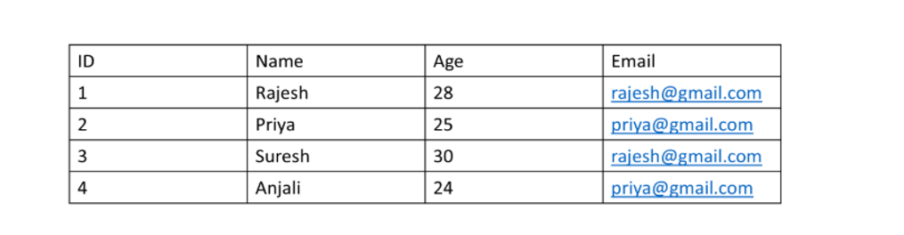

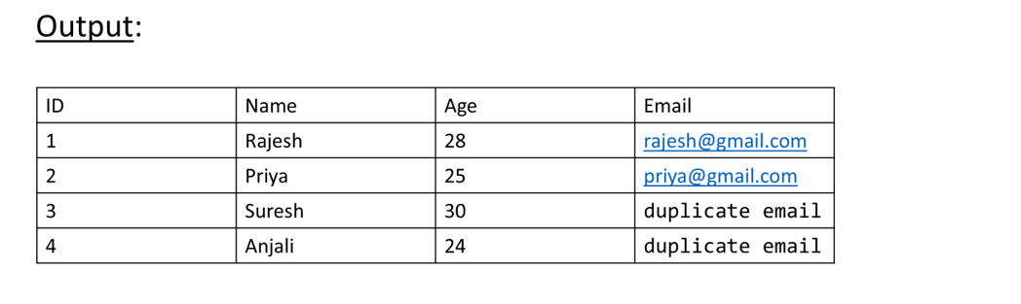

Solution 1:

CREATE TABLE Persons (
id INT PRIMARY KEY,
name VARCHAR(50),
age INT,
email VARCHAR(100)
);
INSERT INTO Persons (id, name, age, email) VALUES
(1, 'Rajesh', 28, 'rajesh@gmail.com'),
(2, 'Priya', 25, 'priya@gmail.com'),
(3, 'Suresh', 30, 'rajesh@gmail.com'),
(4, 'Anjali', 24, 'priya@gmail.com');

Approach 1

SELECT * FROM PERSONS
-- TRUCATE TABLE PERSONS
UPDATE Persons
SET EMAIL='DUPLICATE EMAIL'
WHERE ID IN(
SELECT P1.id FROM PERSONS AS P1
JOIN Persons AS P2
ON P1.id>P2.ID AND P1.EMAIL=P2.EMAIL
);

Approach 2:

WITH cte AS (
SELECT *,
ROW_NUMBER() OVER(PARTITION BY email ORDER BY id) AS rn
FROM Persons
)
UPDATE Persons
SET email = 'DUPLICATE EMAIL'
WHERE id IN (
SELECT id FROM cte WHERE rn > 1
);

SELECT * FROM PERSONS

